Lab 3

**Snapshots of Application’s test cases:**

Picture 1: Concurrency Exception

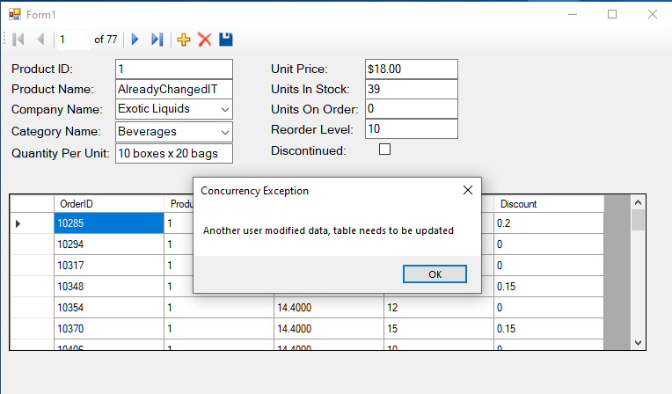

Picture 2: No Null Exception: null value in **not null** column

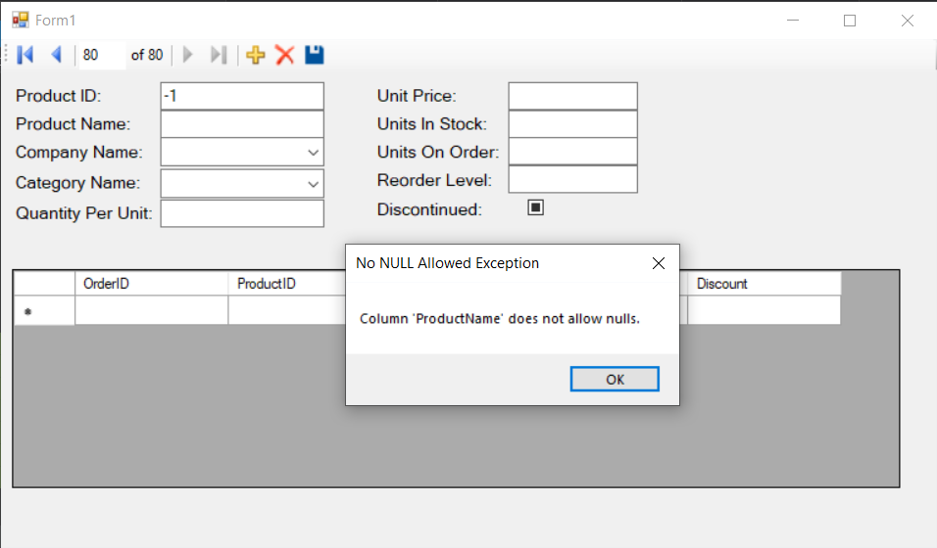

Picture 3: Deleting Record Conflict with FOREIGN KEYS (SQL DELETE Exception)

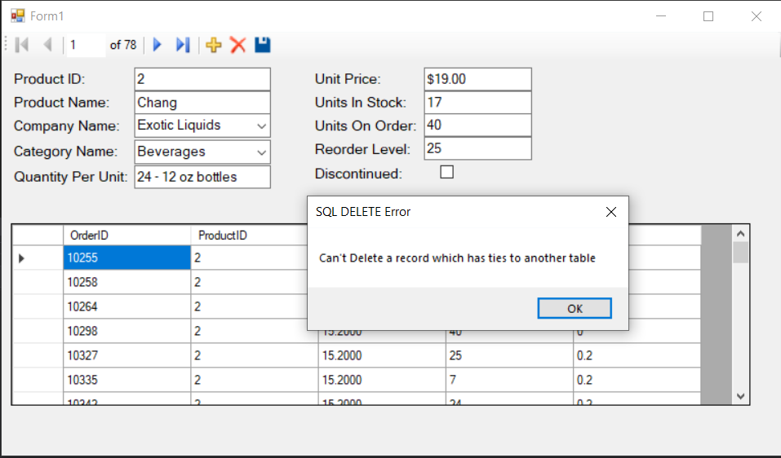

Picture 4: Inserting negative value into UnitPrice

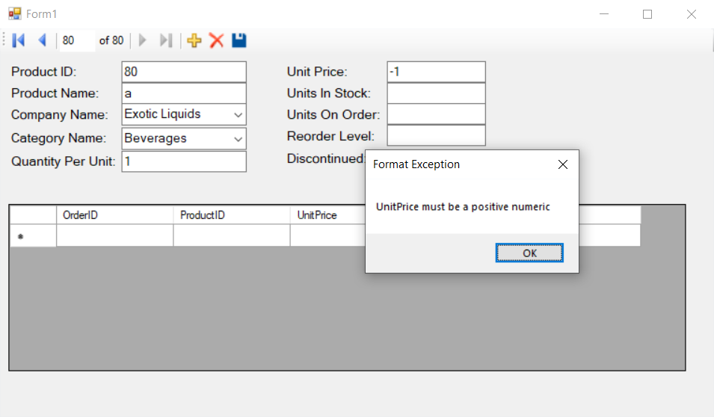

5: Adding Record

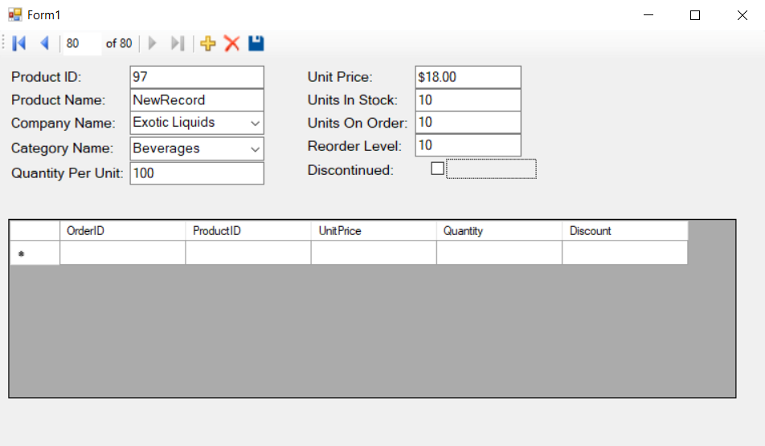

Confirmation from database:

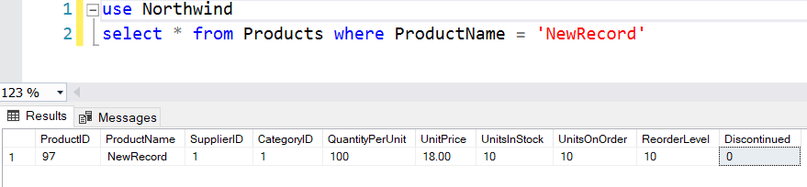

6: Delete added Record

